Press Contact: Chanda Chevannes, Producer/Director chandachevannes@icloud.com (416) 294-9121
Available for Interview: Sandra Steingraber ssteingraber@ithaca.edu (607) 351-0719
Publicity Stills: https://spaces.hightail.com/space/KvsKGKEm75

April 25, 2018
FOR IMMEDIATE RELEASE:

UNFRACTURED, a triumphant anti-fracking documentary, wins big at EarthxFilm festival in Texas!

Filmmaker Chanda Chevannes to use the $5,000 prize for
50 grassroots community screenings of the film.

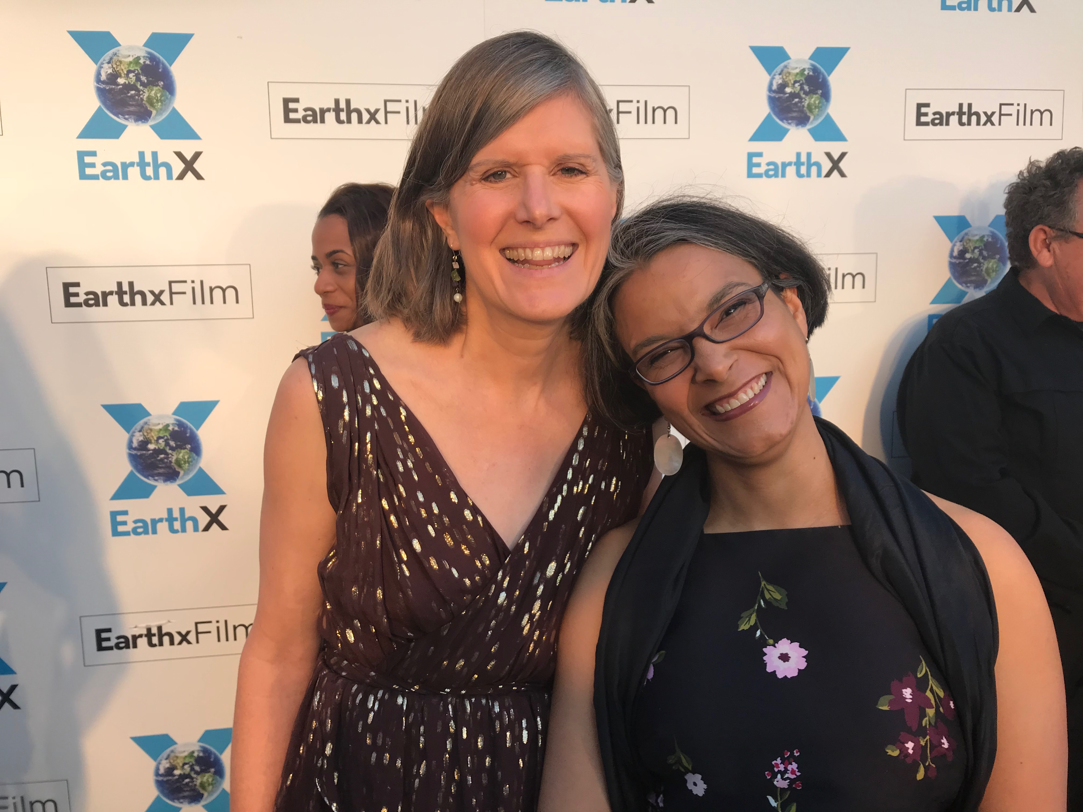
Sandra Steingraber (film subject) and Chanda Chevannes (filmmaker) on the EarthxFilm Green Carpet.
Photo: Jon Bowermaster

Dallas, TX – This weekend, Texas’ EarthxFilm festival awarded its top prize to UNFRACTURED. The film, directed by Chanda Chevannes, screened three times at the Dallas-based environmental film festival.

Even in the heart of fracking country, people’s eyes are opening to the harms of drilling and fracking, and opposition is mounting.

At the awards ceremony, members of the Best Feature Jury praised the film, saying “This remarkable documentary does more than help us comprehend the fracking industry and its immediate impact on our environment. UNFRACTURED is also a deeply moving and revealing portrait of the human cost of uncompromised activism and the anatomy of personal sacrifice. Ultimately, UNFRACTURED carries with it a hopeful message about how advocacy, protest, and demonstration can—and must—truly change the world.”

The award comes with a $5,000 prize. Inspired by the growing opposition she has witnessed, including recently in Texas, filmmaker Chanda Chevannes said she will use the funds to bolster the grassroots movement, by offering the rights to screen UNFRACTURED free of charge to 50 grassroots organizations. Chevannes intends to work closely with those on the frontlines of the battle against the fossil fuel industry, in the hopes of inspiring more women and men to join the fight.

A triumphant documentary about fighting with your whole heart, UNFRACTURED follows biologist and mother Sandra Steingraber as she reinvents herself as an outspoken activist and throws herself into the fight against fracking in New York State.

Both Chevannes and Steingraber attended the festival and spoke during a post-screening Q&A on Saturday April 21. The team was honored to have the UNFRACTURED screen in Dallas, where it received an enthusiastic response from the audience during its Texas Premiere.

Prior to the screening, Steingraber was invited to speak on the risks and harms of fracking by Liveable Arlington, a grassroots group in a suburban community just outside of Dallas. Steingraber also toured Arlington, which is home to approximately 325 oil and gas wells, many located not much farther than 300 feet of homes, along with three major compressor stations (one in Arlington and two at its boundary) and miles of gas gathering pipelines carrying unodorized gas.

In her award acceptance statement, Chevannes said, “It’s incredibly uplifting to know that even deep in the heart of Texas—a state that is home to the oil and gas industry—a film about the fossil fuel resistance is being celebrated.”

After receiving the award, Chevannes said, “Texas is a place where the oil and gas industry makes its presence clearly—and overwhelmingly—felt. But this award is a powerful signal that people are awakening to the risks and harms of fracking, and the urgent need to stop fossil fuel extraction. Even in Texas, where fracking was first developed, there is an unstoppable grassroots fight being waged for an unfractured future.”

Chevannes dedicated the award to Liveable Arlington, led by residents who are fighting their own David and Goliath battle against the oil and gas industry in Texas.

Sandra Steingraber said, “Fracking is a Neanderthal technology that uses drinking water as a club to smash apart bedrock in order to extract climate-killing fossil fuels. Science shows that, wherever it is practiced, fracking pollutes the air, contaminates water, injures workers, and makes people sick. UNFRACTURED brings to life the story of how we stopped fracking in New York, and to see that story—and the science behind it—resonate so deeply with our audience in Texas is, I believe, a very hopeful sign of the times. Even the tech guys inside the sound booth were applauding.”

About UNFRACTURED
Total running time: 91 minutes
Format: DCP, Color, 16:9, 5.1
Production Company: Chanda Chevannes Productions

A triumphant documentary about fighting with your whole heart, UNFRACTURED follows biologist and mother Sandra Steingraber as she reinvents herself as an outspoken activist and throws herself into an environmental war that many believe is unwinnable.

Hailed as a “toxic avenger” by Rolling Stone, Sandra Steingraber quickly emerges as one of the leaders of New York’s anti-fracking movement. Determined to win an uncompromising battle with the oil and gas industry, she devotes all of her time, energy and money to the campaign. But as the film opens, her personal life is thrown into crisis when her husband suffers one stroke after another. Although she knows her family needs her at home, Steingraber won’t stop—not until she and her allies win a statewide ban on fracking. And when the win came on Dec. 17, 2014, with Governor Andrew Cuomo’s announcement of a statewide ban on fracking, the cameras were rolling to capture it all.

UNFRACTURED had its World Premiere as the opening night gala film at Planet in Focus International Environmental Film Festival in Toronto, where it also took the top prize, Best Canadian Feature Film. It had its International Premiere at DOC NYC, America’s largest documentary film festival. It has since been screened across the US, in Europe, and Australia.

UNFRACTURED was produced with the support of Ceres Trust, Canada Council for the Arts, The People’s Picture Company, and Marilynn J. Magoon & Duncan J.J. Magoon. Chevannes’ festival travel during April has been sponsored in part by the Canada Council for the Arts.

About EarthxFilm

EarthxFilm is a 21st century film festival that uses the power of film and emerging media to raise awareness of environmental and social global issues. Incisive, powerful storytelling is crucial to a livable future on this earth and EarthxFilm believes in taking the audience from an emotional reaction to action in an entertaining and memorable way.

From Friday, April 13 to Sunday, April 22, 2018, EarthxFilm presented over 60 feature and short documentaries at screenings and events across Dallas, culminating at EarthX, the largest environmental gathering in the world.

About Director Chanda Chevannes

Chanda Chevannes is a Canadian filmmaker, writer and educator. Her documentaries address complex social issues while amplifying women’s voices. Chevannes’ first feature-length film, Living Downstream, won several awards (including a Gracie for Outstanding Documentary from the Alliance for Women in Media Foundation), screened publicly over 200 times, and was broadcast on six continents. Previously, while living in sub-Saharan Africa, Chevannes created educational films on gender-based violence. Thousands of grassroots organizations are using these films, which have contributed to tangible social change. Chevannes’ writing includes a column for Troy Media, screening guides for her films, and two blogs for the NFB’s CitizenSHIFT website. She is a graduate of Sheridan College’s Media Arts Program and an instructor at Centennial College’s Story Arts Centre. www.chandachevannes.com

About Sandra Steingraber
Biologist, mother and cancer survivor, Sandra Steingraber, Ph.D., is an internationally recognized authority on the environmental links to public health. Holding a doctorate in biology and a master’s degree in creative writing, she has written three books about human health and the environment, including Living Downstream, which was released as a documentary film in 2010. Steingraber has won numerous awards for her environmental health research and writing, including the Heinz Award, Chatham College’s Rachel Carson Leadership Award, the Hero Award from the Breast Cancer Fund, and the Environmental Health Champion Award from Physicians for Social Responsibility. She is the co-founder of New Yorkers Against Fracking and Concerned Health Professionals of New York and currently serves as science advisor to Americans Against Fracking. She has worked closely with the California Breast Cancer Research Program, provided Congressional briefings, lectured widely in medical schools and college campuses, and testified before the United Nations, the U.S. Congress and the European Parliament. A contributing editor for Orion magazine, Steingraber is a Distinguished Scholar in Residence at Ithaca College in Ithaca, New York. www.steingraber.com

Official Website: https://www.unfractured.com/
Film’s Facebook Page: https://www.facebook.com/Unfractured
Subject’s Facebook Page: http://www.facebook.com/ssteingraber
Director’s Twitter: https://twitter.com/chandachevannes
Subject’s Twitter: https://twitter.com/ssteingraber1

###

